**Phillips Education Leads India’s Technical Skill Revolution for a Future-Ready Workforce**

***Prominent leaders from government, industry, CSR foundations, social impact funds, and academia convene to deliberate on India’s skilling imperative across Aerospace, Defence, and Emerging Technologies***

**Mumbai, 18th September 2025:** Phillips Education and Arthan convened The G.R.O.W.T.H. Dialogue – Gathering Resources and Opportunities for Workforce Transformation & Humanity at Taj Lands’ End, Mumbai. The dialogue was graced by Shri Saurabh Bahuguna, Hon’ble Minister for Skill Development & Employment, Uttarakhand, along with 40 prominent leaders from government, industry, academia, and the CSR sector for a high-level exchange of perspectives on skilling priorities, partnerships, and policy action.

Today, India stands at a pivotal juncture. With visionary ambitions to become a technological and industrial powerhouse—especially across aerospace, defence, semiconductors, renewables, and AI—the focus on equipping its workforce with relevant skills has never been more crucial. The World Economic Forum projects that by 2030, **44% of the skills used today will become obsolete**. Meanwhile, India targets a **$64 billion semiconductor market by 20261, a $70 billion aerospace and defence sector by 20302, and 500 GW of renewable energy by 20303**. These ambitions underscore the urgency to prepare a workforce capable of sustaining rapid transformation.

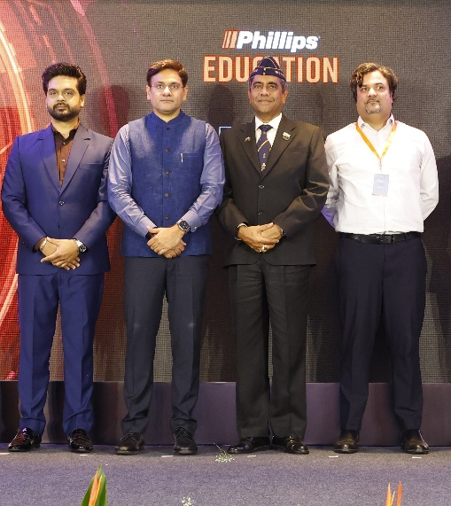

*(L-R) Rakshit Kejriwal, Global President Phillips Education; Shri Saurabh Bahuguna - Honorable Skill and Employment Minister – Uttarakhand Government; Dr Cdr Devendra Singh - R&D Director & Aerospace & Defense at Visvesvaraya Technological University; Mr Satyam Vyas - Founder and CEO Arthan*

Against this backdrop, the dialogue sought to address a central, pressing question that will shape the country’s future:

Can India Become a Global Superpower Without Skilled Manpower or Workforce?

Effective skilling, as recent McKinsey analysis suggests, has the potential to add **$500 billion to India’s GDP by 2030**, making it a matter of both economic growth and national security. The urgency of specialized skills was highlighted with examples from aerospace and defence—where **a single modern aircraft requires over 40 lakh precision parts4** and an **estimated shortage of 15 lakh professionals in defence cybersecurity is projected by 20265**.

Shri Saurabh Bahuguna remarked:

“India’s demographic dividend is our greatest strength, but it will only yield results if we channel it through the right skilling pathways. By enabling industry-academia partnerships and investing in practical, job-ready training, we can ensure that our youth are not just employable but ready to lead India’s growth story on the global stage.”

Speaking at the event, **Rakshit Kejriwal, Global President, Phillips Education**, added:

“India today stands at the threshold of a new industrial era – in aerospace, defense, semiconductors, renewables, and AI. Each of these sectors are several billion-dollar opportunities, but they demand one thing above all else - skills. The world’s youngest workforce can either remain a number or be a gamechanger. At Phillips Education, we believe that India’s growth story will be defined by how effectively we prepare our workforce for the future and are committed to equip India’s workforce with skills of tomorrow. For this, we urgently need a National Skilling Coalition - government, industry, academia, and CSR – working together. If Infrastructure builds nations, Skills build civilizations.”

**Satyam Vyas, Founder & CEO of Arthan** emphasised that skilling is not just about employability, it is about building the workforce that will power India’s future. As the world navigates transitions in climate, technology, and demographics, investing in people becomes our strongest lever for inclusive and sustainable growth. Through collaborative platforms like this, we aim to bring together stakeholders to ensure that young people, women, and underserved communities are not only part of the workforce but are leading it.

The keynote also spotlighted Phillips Education’s own initiatives:

* **Centers of Excellence** across India in Advanced Manufacturing & Emerging Technologies such as Renewable Energy, where 100% of students have secured high-quality jobs.
* **Industry-Academia Partnerships**, including an R&D lab with IIT-Bombay in hybrid technology combining CNC machining and 3D printing for the aerospace sector.
* **Skilling for Inclusion** programs aimed at underserved communities to empower youth and women with entry-level technology training.

The dialogue concluded with a vote of thanks and a networking dinner, fueling opportunities for collaboration beyond the stage. Moving forward, Phillips Education and Arthan remains committed to building platforms for continuous stakeholder engagement, uniting visionaries to ensure India’s workforce is ready for the future and the country’s ambitions are matched by its human capital.

**\*\*Ends\*\***

**Link <**[**image and collateral**](https://drive.google.com/drive/folders/19yMpcqZqIT47W3kdt5-fzk1BZLEaZLo6)**>**

Data source:

**1 According to a joint report by Counterpoint Research and the India Electronics & Semiconductor Association (IESA)**

**2 Data from MM India Research**

**3 Data shared during United Nations Climate Change Conference (COP26) commitment**

**4**AEROREPORT Magazine

**5NASSCOM-Zinnov report's**

**About Phillips Education:**

Phillips Education is a global leader in manufacturing technology education, dedicated to bridging the skill gap between industry needs and workforce capabilities. With a strong focus on machining, additive manufacturing, robotics, and automation, Phillips Education delivers industry-synchronized training and certifications designed for both aspiring learners and seasoned professionals. Through its Centers of Excellence, MAKE Labs, and tailored training academies, the organization works closely with enterprises, universities, and CSR partners to build scalable skilling ecosystems. Its integrated model combines hands-on technical training, digital learning platforms, job-connect services, and internationally recognized certifications to ensure learners are industry-ready from day one. As part of Phillips Corporation, Phillips Education leverages global expertise and partnerships to shape a workforce equipped for advanced manufacturing and emerging technologies, while also driving inclusion by creating opportunities for youth, women, and underserved communities.

_______________________________________

For more information, please get in touch with us at:

Vikramjit Kundu | vikramjit@madchatter.in | Phone number +919082173029